BBD Identification Guide

Beer Bottle - Neck/Shoulder BBD
Best Before Dates on Beer bottles are generally found on the Neck/Shoulder of the bottle (front or back of bottle)
Brewery Codes examples 0222, 0213, 026 or can be letters LB0126
Examples showing where the Best Before Date (BBD) or product code is printed.
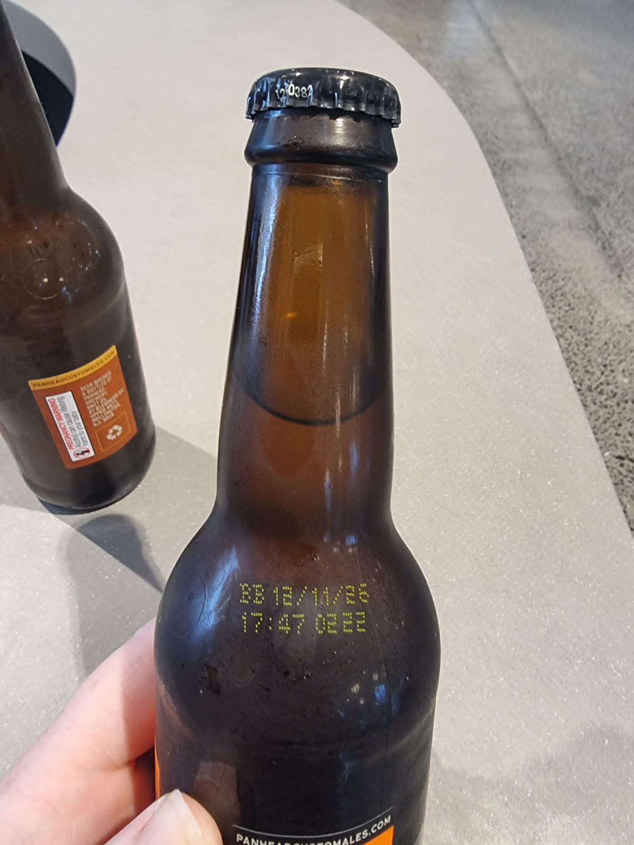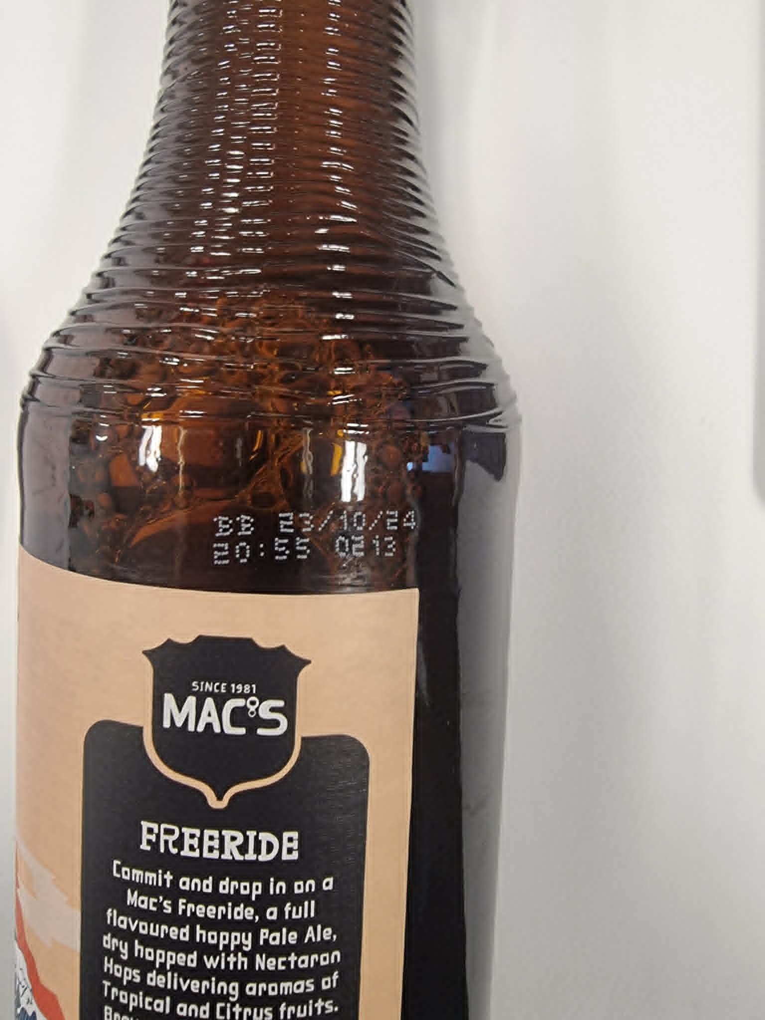

Beer & RTD Cans - Base BBD Example
Best Before Dates on cans are found on the bottom of the can
Brewery Codes examples 0222, 0213, 026 or can be letters LB0126
Example showing where the Best Before Date (BBD) or product code is printed.
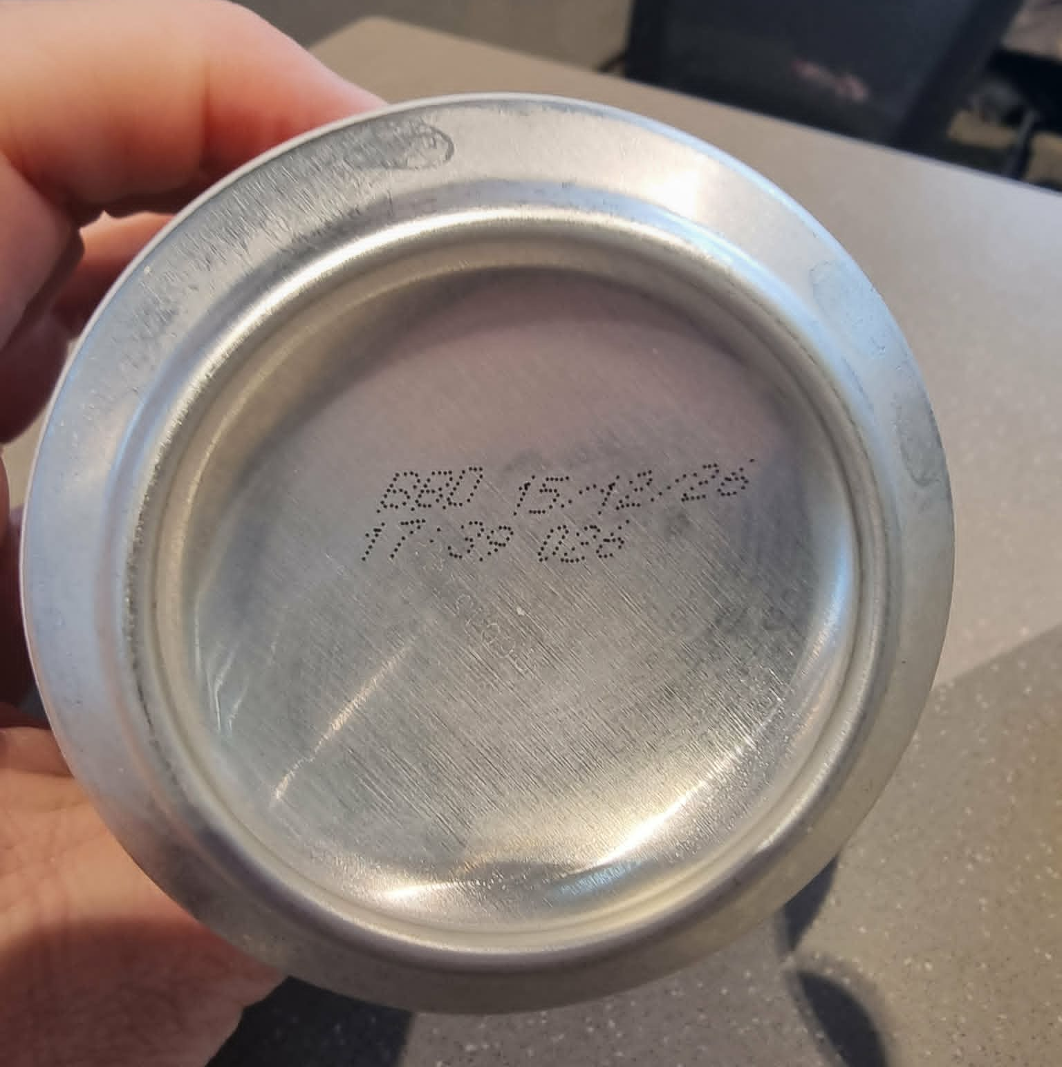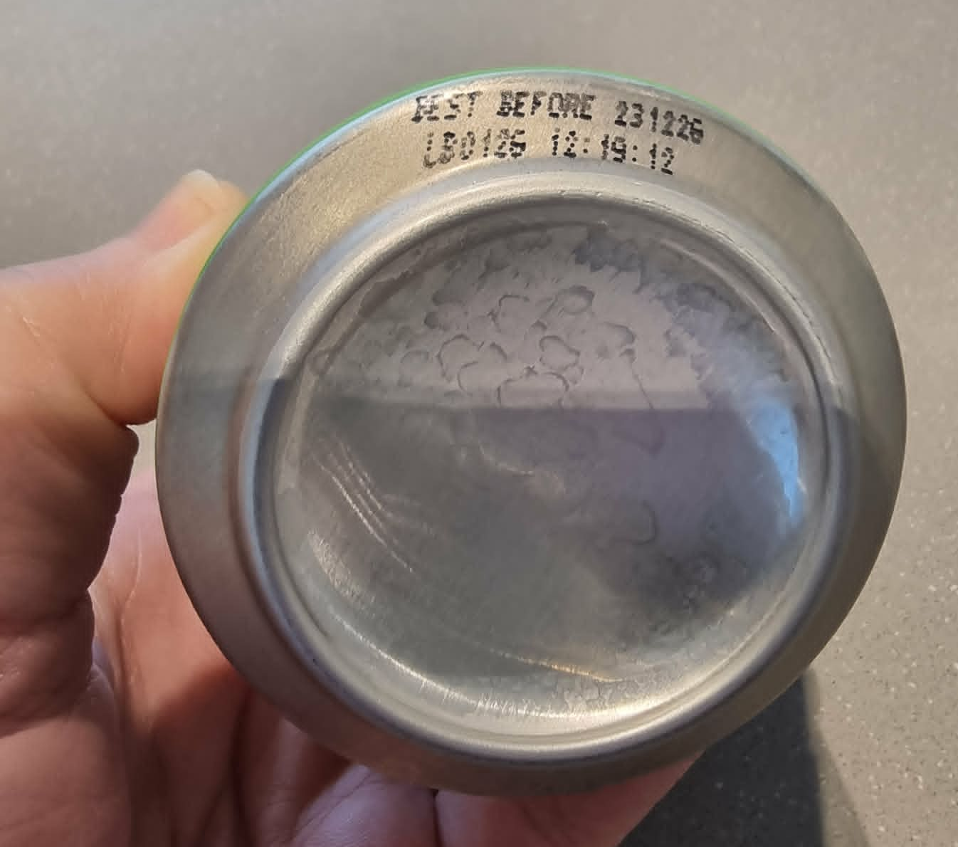

Wine Bottle – Batch Code Example
Batch Codes are generally located near the base of the bottle (front or back of bottle) and have the following format
LXXXX PXXXX XX:XX
TZXXX XXXXX XX LXXXX XX:XX
Example showing where the batch code is printed.
